Newsletter
Bluffton Lions Club
www.ohiolions.org
www.blufftonlions.org
www.blufftonlionsfoundation.org

March
2020
2019-2020 Officers & Board Members:
President-Patty Navin; V.Pres-Stephanie Larcom; V.Pres-Gene Long; V. Pres-Corwin Croy; Secretary-Barbara Plaugher; Treasurer-Clair Winebar; Lion Tamer-Elaine Harris; Tail Twister-Greg Averesch; Board Members: 2 yr-Dan Diller; 2 yr-Robert Stahl; 1 yr-Tracy Steele; 1 yr-Jim Bemiller;
Immediate Past President-Christina Walton; Foundation President-Dick Ramseyer
Editor-Barbara Plaugher

April Birthday:
John Hochstetler 4/1 Don Snyder 4/16 Jim Bemiller 4/26

UPCOMING EVENTS:
Due to the coronavirus restrictions, all Lions events have been cancelled.
Upon lifting these restrictions, the scheduling of EVENTS WILL BE SENT TO YOU BY E-MAIL AS SOON AS POSSIBLE

50/50 CHARITY RAFFLE WINNERS: April winners are as follows: $100 winner Sawyer Goldsberry ticket sold by Lion Sawyer Goldsberry; $50 winner Rita Dietrich ticket sold by Lion Corwin Croy; $30 winner Mara Minnig ticket sold by Lion Mike Minnig; $20 winner Dave Huber ticket sold by Lion Gene Long.

BOARD MEETING: At the March 10th meeting the board voted to pay the $3,000 pledge to Blanchard Valley Health System. Pancake/sausage breakfast scheduled for March 17th on hold due to coronavirus restrictions.
Citizen of the Year plans will continue. The banquet may need to be rescheduled at a later date.
Nomination Committee to meet under Lion Dick Boehr’s guidance.
May 16th bike rodeo will need volunteers at Buckeye Park from 8 until noon. See Lion Patty Navin to assist with this project.

MARCH 3RD MEETING: Lion Greg Denecker, Superintendent of Bluffton School District, was the speaker for the March 3rd meeting. He introduced the new teachers in the school system. His topics for this meeting included: School safety; Social Emotional Learning; State Report Card; Voucher program; ED Choice Program; and Funding program of the school.

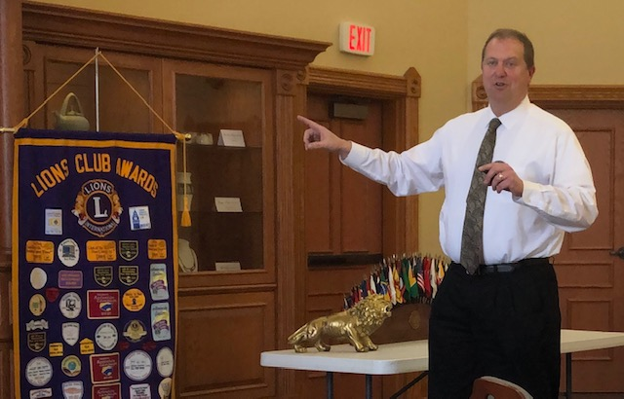

Editor’s note:
A nominating committee is working on the slate of officers for this coming year. I will be e-mailing the slate to all members. Two weeks after mailing this slate of new officers I will again mail the slate and ask for a vote. If you wish to submit a name to the slate after the first mailing, this will be taken back to the nominating committee. We hope to be able to have our officers submitted to LCI before May 1st. Thank you for serving your club. 

