Newsletter

*Bluffton Lions Club*

[**www.ohiolions.org**](http://www.ohiolions.org)

[***www.blufftonlions.org***](http://www.blufftonlions.org)

February 2025

2024-2025 Officers & Board Members:

President-Jackie Bourassa;  **V. Pres-John Rich; V. Pres- Dwain Hall; V. Pres-Greg Denecker; Secretary-Barbara Plaugher; Treasurer-Ed Yeager; Lion Tamer-Mark Bourassa; Tail Twister-Dennis Morrison; Board Members: 1 yr.-Tracy Steele; 1 yr.- John Hochstetler; 2 yr.- Mark Bourassa; 2 yr.- Jerry Szabo. Editor-Barbara Plaugher**

**March Birthday:**

**Ryan Lowry 3/6 Corwin Croy 3/10 Mitch Kingsley 3/19**

**Neil Reichenbach 3/24**

**March Anniversary:**

**Ron Lora 3/22**

**UPCOMING EVENTS:**

**March 4th: LEO Club of Bluffton High School charter night with induction of members and installation of officers with reception to follow. Town Hall 5:30 PM – 7:00 PM. Out of town guest speakers and other lions invited. RSVP to Lion Jackie Bourassa.**

**March 8th: Cabinet meeting Town Hall 9 am,**

**March 18th: Club meeting Town Hall noon. Speaker Dave Sycks talking about the Bluffton School music program. 50/50 charity raffle draw.**

**April 15th: Citizen of the Year program. Mark your calendar. If you have candidates, contact Lion John Rich.**

**February Charity Raffle:**

**$100 David Dudenhefer ticket sold by Lion John Rich**

**$50 Teresa Plaugher ticket sold by Lion Barbara Plaugher**

**$30 Allyse Aversch ticket sold by Lion Greg Averesch**

**$20 Candice Luginbill ticket sold by Lion Dwain Hall**

**Board Report:**

**A request to remove Dr. Alan Yoder from membership was accepted by the Board.**

**Sponsorship of the District Convention for a table and ad were approved by the Board. Delegates for the convention available are 5. Those interested contact Lion Barbara Plaugher.**

**The All-Inclusive Playground pledges and payments are current at $33,173.**

**Pancake breakfast planned for May 10th with the craft show.**

**Citizen of the Year program will be held on April 15th.**

**Spring cleanup will be held in April with Lion Andrw Rager coordinating this project.**

**Festival of Wheels planning with Lion Greg Denecker and Dan Groman, June 14th.**

**February 4th Meeting:**

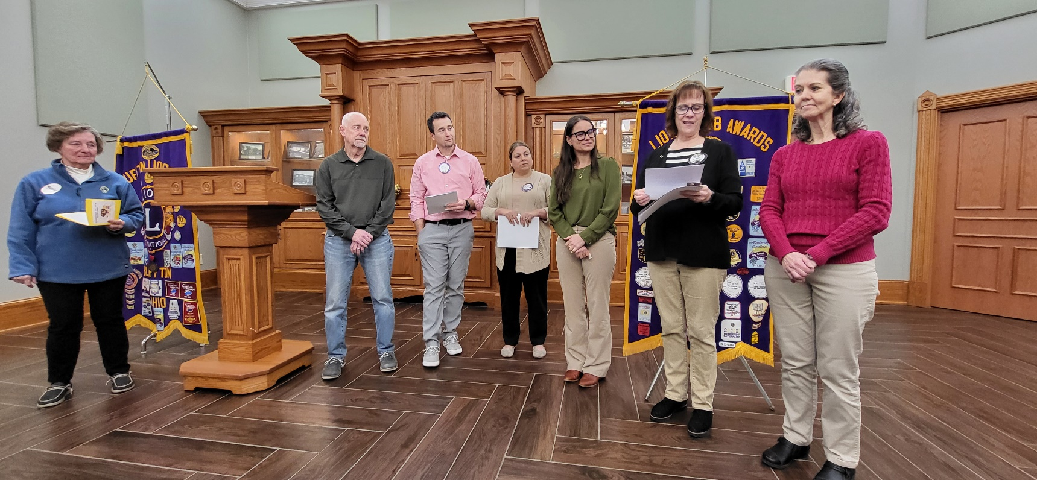

**This meeting was held at 6 PM on February 4th. Installation of new members by District Governor Sue Davis. Bios of the new members below. DG Sue also was our speaker, sharing information on the district, state and international news. From L to R..DG Sue Davis; Larry Hoffman with sponsor Lion Andrew Armstrong; Lion Natalie Armstrong sponsor of Laura Dagani; Lion Jackie Bourassa sponsor with Brigette Hoff. New Member: Larry Hoffman retired after 40 yrs as a Certified Public Accountant. He is the elected Fiscal Officer for Richland Township. Past community boards of Bluffton School; Phi Theta Pi Fraternity; Bluffton Soccer Club; Bluffton Area Chamber of Commerce; Bluffton St. Mary’s Church. Wife Marcy and 3 children live in Bluffton. Larry enjoys hiking, running, pickleball, gardening and time with family. New Member: Laura Dagani graduated from Cory Rawson, attended Bluffton Univ and Univ Toledo Medical college and later Family Nurse Practitioner certification. She has worked at Blanchard Valley Hospital for 20 years. Her daughter is now a Junior at Bluffton High School and a Leo Club member. She enjoys helping with the Leo Club, volunteering for her daughter’s extracurriculars, hiking and kayaking. New Member: Brigette Hoff raised in Bluffton, earned her B.A. from Akron Univ and M.A. from Bluffton Univ. Along with new lion member husband, Scott, have 3 children and grandchildren. Brigette is currently teaching at Bluffton High School for 21 yrs, out of 28 yrs teaching. She has been a 4-H advisor for 31 years. She enjoys traveling, baking, playing piano and trumpet, and time along with family.**

**February 18th: Erin Burkholder from Crime Victim Services presented the program for this club meeting. Crime Victim Services advocate prevention, advocacy and outreach. If you want to be a community volunteer and speak up for the best interest of an abused child, training is given 4 times a year. Volunteers are always needed. New Member: Scott Hoff was raised into an Air Force family and home was many places. He attended Univ of Akron, earned a B.A. and masters from Univ of Dayton. Met his wife, new lion’s member Brigette, at Akron. They have 3 children and grandchildren. He recently retired from teaching at Bluffton High School where he was the curriculum director and co-founder of Ocean focus. He enjoys traveling, reading and spending time with family. New Member: Renee Matthews raised in Bluffton, attended Anderson Univ, IN received a bachelor’s degree in Social Work. Married lion Brendon Matthews and they have 3 daughters. Renee returned to Rhodes State College for her RN degree and has worked at Bluffton Hospital for 18 years. She currently is the Bluffton Hospital Campus Administrator. She volunteers on the Bluffton YMCA advisory committee, Bluffton Chamber of Commerce Board, Bluffton Univ Nursing Advisory Board.**

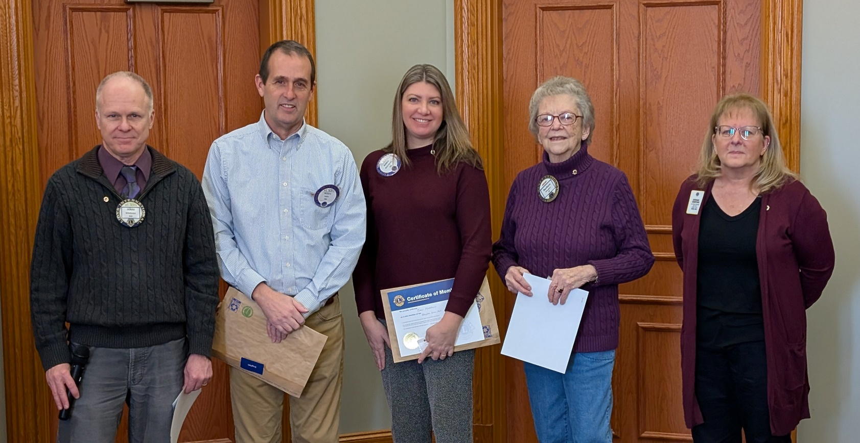**L to R: Lion Mark Bourassa sponsor with Scott Hoff; Renee Matthews with Sponsor Lion Barbara Plaugher; IPDG Deb Crawford. (It was the day for PURPLE!)**



**PLEASE CONSIDER ATTENDING THE BLUFFTON HIGH SCHOOL LEO CHARTER NIGHT. THE LEOs ARE LOOKING FORWARD TO MEETING THE LION MEMBERS. WE ARE SO PROUD OF THIS GROUP OF YOUNG LEOs AND THE SERVICE THEY ARE PROVIDING FOR THE COMMUNITY.**

**Lion Barbara**