Newsletter
Bluffton Lions Club
www.ohiolions.org
www.blufftonlions.org
www.blufftonlionsfoundation.org

August 2013
2012-2013 Officers & Board Members:
President-Mitch Kingsley; V. Pres-Chad Grieser; V. Pres-Stephanie Larcom; V. Pres-Sarah Foster; Secretary-Elaine Brubaker; Treasurer-Lowell Hostetler; Lion Tamer-Arliss Plaugher; Tail Twister-Greg Averesch; Board Members: 2 yr-Mark Alliman & Phil Zimmerly; 1 yr-Ron Lora & Katie Keifer; Foundation President-Dick Ramseyer; Editor-Barbara Plaugher

September Birthdays:
Gary Bishop 9/2 Jerry Szabo 9/4 Dan Diller 9/5
John Harris 9/8 Dennis Gallant 9/18 Brendon Matthews 9/22
Greg Averesch 9/28 Ed Yeager 9/28 Jeff Joseph 9/29
September Anniversaries:
Bob Amstutz 9/2 Dan Diller 9/5 Jamie Mehaffie 9/12
Alan Yoder 9/17 Mark Alliman 9/23 Stan Naylor 9/25
Corrine/Dick Boehr 9/28 John Harris 9/29 Phil Weisenbarger 9/29

UPCOMING EVENTS:
Corvette Charity Raffle Sales continue until October.
September 3rd: Club meeting at Maple Crest. Induction new members. Program will be presented by Andy Chaffe on his “Ironman Experience”.
September 8th: Sure Sight training at Plaugher home 2 pm
September 9th: Sure Sight screening at Bluffton Day Care Center 9:30 am
September 10th:Sure Sight screening at Allen East Grade School 8:00 am
September 11th: Sure Sight screening at Hilty Home Day Care in Pandora 8:00 am
September 16th: Sure Sight screening at Bluffton Pre-School Methodist Church 9am & 1 pm
September 17th: Sure Sight screening at Bluffton Pre-School Methodist Church 9am
September 17th: Club meeting at Maple Crest. Program will be presented by Andy Chapel-Dyck on “Small Houses”.
September 18th : Sure Sight screening at Bluffton Grade School 8:30 am
***A note involving the upcoming events of Sure Sight Screening above. There is a possibility of approximately 300 children, 3 to 6 year olds within and surrounding our community, that will be screened by the Bluffton Lions club members on the dates listed above. If any of our members would be interested in assisting with this fun, volunteer project, please contact Lion Barbara Plaugher. The time frame for each day will be no more than one to two hours to complete the screening. This is the second year of screening, and each facility was very happy to have the team return. Approximately 10% of the children screened last year were referred to see an optometrist for more evaluation. If you want to assist in caring for our children, you will find this project worthwhile of your time and energy.


Board Report:
Board discussion on meeting place and meal of the club with no decision at present.
New members approved: Kyle Leatherman, Omar Khokhar, Mike Minnig. To install in Sept.
Eye screening dates set. Audit report for previous Lion’s year given and approved.
- A replacement for Vice President of Projects Sara Foster by Rachel Webster will be voted upon at the next club meeting.

Information on Donations:
This past year the Bluffton Lions Club made donations to many organizations. Each year the Board determines their choice for humanitarian donations. This report is to briefly explain the purpose of these organizations from last year:
LCIF – This is the Lions Clubs International Foundation. Funds donated to this organization go to provide disaster relief in countries both in the US and all over the world. Our Sight First project to provide sight care, the measles initiative to eradicate measles and other projects serving our youth are of high importance. Preserving sight, serving youth, disaster relief and humanitarian efforts are fulfilled with this donation.
VOSH-Ohio This donation goes to our local state organization and helps in purchasing special glasses and equipment to take to third-world countries with teams to provide free eye care.
Ohio Sight/Hearing – This organization along with Pilot Dogs provide sight care in the State. The Sure Sight project to examine all 3 to 5 year olds for “lazy eye” was developed here and 10 special examination units were purchased to be used in Ohio. Dogs for the blind get funding through this organization.
Ohio Lions Foundation – This organization provides grants for disaster relief in our state, scholarships, low vision reader grants, support the Blind Marching Band and School for the Blind support.
Ohio Diabetes Fund – Provides funds for eye research, diabetes awareness programs.
Ohio Lions Eye Research – Provides funds for research into cause, treatment and cure of diabetic eye disease, macular degeneration and others. This is a state organization
North West Ohio Eye care – Provides funds for local needs for eye care in northwest Ohio, as cataract removal, machines for magnification for individuals, and general eye care assistance.
Lions International Relations – Funds donated here are divided up among the OSU Student VOSH, Amigos and VOSH-Ohio. These funds go to international projects.

August 6th Meeting:
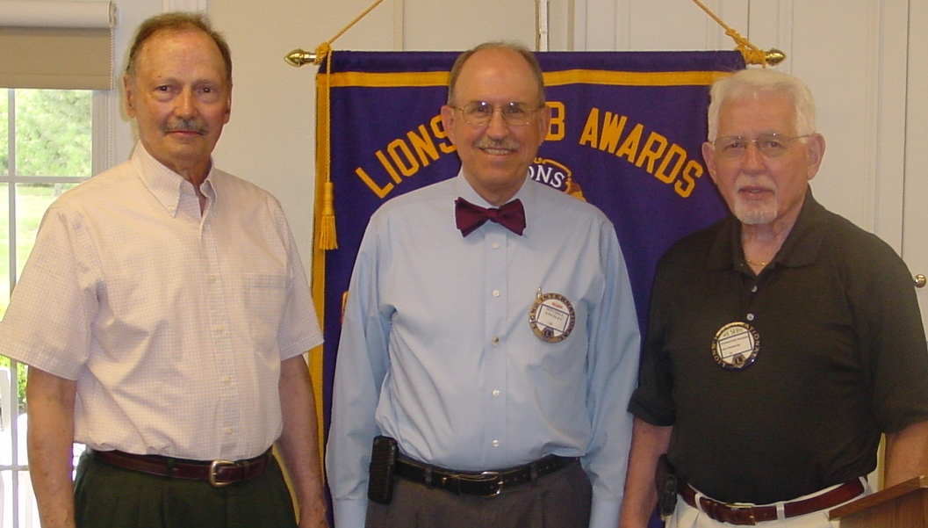
New member Ted Cunningham, Lion President Mitch Kingsley, Sponsor Lion Dick Ramseyer
At the August 6, 2013 Bluffton Lions club meeting, members enjoyed a presentation by Bluffton University’s head volleyball coach Steve Yarnell. Lion Steph Larcom, VP for club programs is Yarnell’s sister. Coach Yarnell talked about his passion for the sport of volleyball, the recruiting of players, the team spirit and his style of coaching. Yarnell is entering his ninth season as head volleyball coach at BU and hold the rank of associate professor in the Health, Fitness and Sports Science Department. Prior to coaching at Bluffton University, Steve was the assistant coach for men’s and women’s volleyball programs at the University of Findlay.
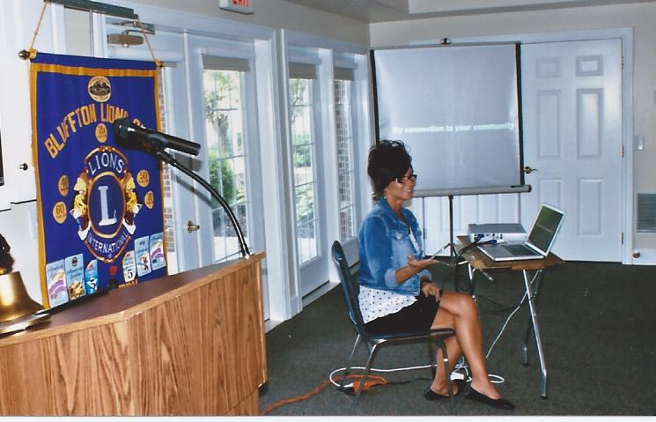
August 20th Meeting:
Speaker Dana Dukes-Norton, Community Relations @ Apollo Career Center, presented the program on “Apollo Career Center – Busting Myth, Building Walls, & Breaking Ground”. She held a very interesting update on Apollo and its advances from inception, along with ratings for the school. Building will be beginning shortly with an offer of public bonds going out for sale.

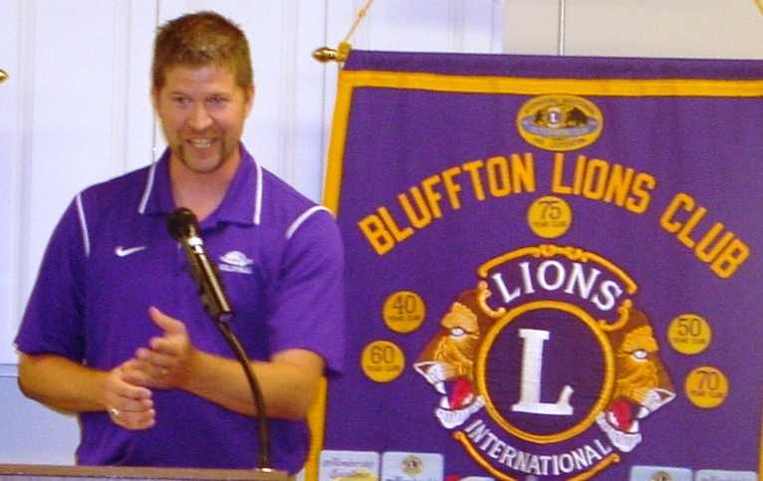
Global Service Action Campaigns:
Lions around the world participate in four special service action campaigns as follows:
Engaging our Youth: Leos and youth in your area assist with projects, allowing youth to develop and lead service projects enables them to learn skills and emphasizes the role of service.
Sharing the Vision: Plan vision health projects. Celebrate World Sight Day in October. Organize vision screening, volunteer at a Recycling Center.
Relieving the Hunger: Food drives, collect and distribute food.
Protecting our Environment: Clean up a highway, plant trees, plan a “EarthDay” event, collect recyclables.
The Bluffton Lions strive to participate in these special service campaigns during the year.

