Newsletter
Bluffton Lions Club
www.ohiolions.org
www.blufftonlions.org
www.blufftonlionsfoundation.org

October 2013
2012-2013 Officers & Board Members:
President-Mitch Kingsley; V. Pres-Chad Grieser; V. Pres-Stephanie Larcom; V. Pres-Rachel Webster; Secretary-Elaine Brubaker; Treasurer-Lowell Hostetler; Lion Tamer-Arliss Plaugher; Tail Twister-Greg Averesch; Board Members: 2 yr-Mark Alliman & Phil Zimmerly; 1 yr-Ron Lora & Katie Keifer; Foundation President-Dick Ramseyer; Editor-Barbara Plaugher
November Birthdays:
Luke Young 11/5 Jay Bricker 11/6 Morris Groman 11/7
Rachel Webster 11/25 Tom Langhals 11/28
November Anniversaries:
Dennis Gallant 11/11 Elaine & Bob Harris 11/14 Praveen Vohra 11/17
Omar Khokhar 11/28
UPCOMING EVENTS:
November 5th – Club meeting 12 noon at the Town Hall
November 10th – District Cabinet Meeting 1 PM @ Mom’s Diner, Archbold
November 19th – Club meeting 12 noon at the Town Hall
November 21st – Northwest Eye Care Foundation meeting 6:30 PM at Lions Building, Napoleon
November 30th – Chicken Bar-B-Q and parade at the “Blaze of Lights”

OCTOBER 1ST MEETING:
The Brauen’s have been operating a very successful gourd operation for 10 years…their enterprise includes raising, harvesting, preserving and marketing crafted Gourds. They operate a show room on the farm and attend major gourd shows in Ohio & Indiana each year. Raising Gourds is a year round business. The Bluffton Lions club held their meeting at the Brauen’s farm. A meal was served by Common Grounds.
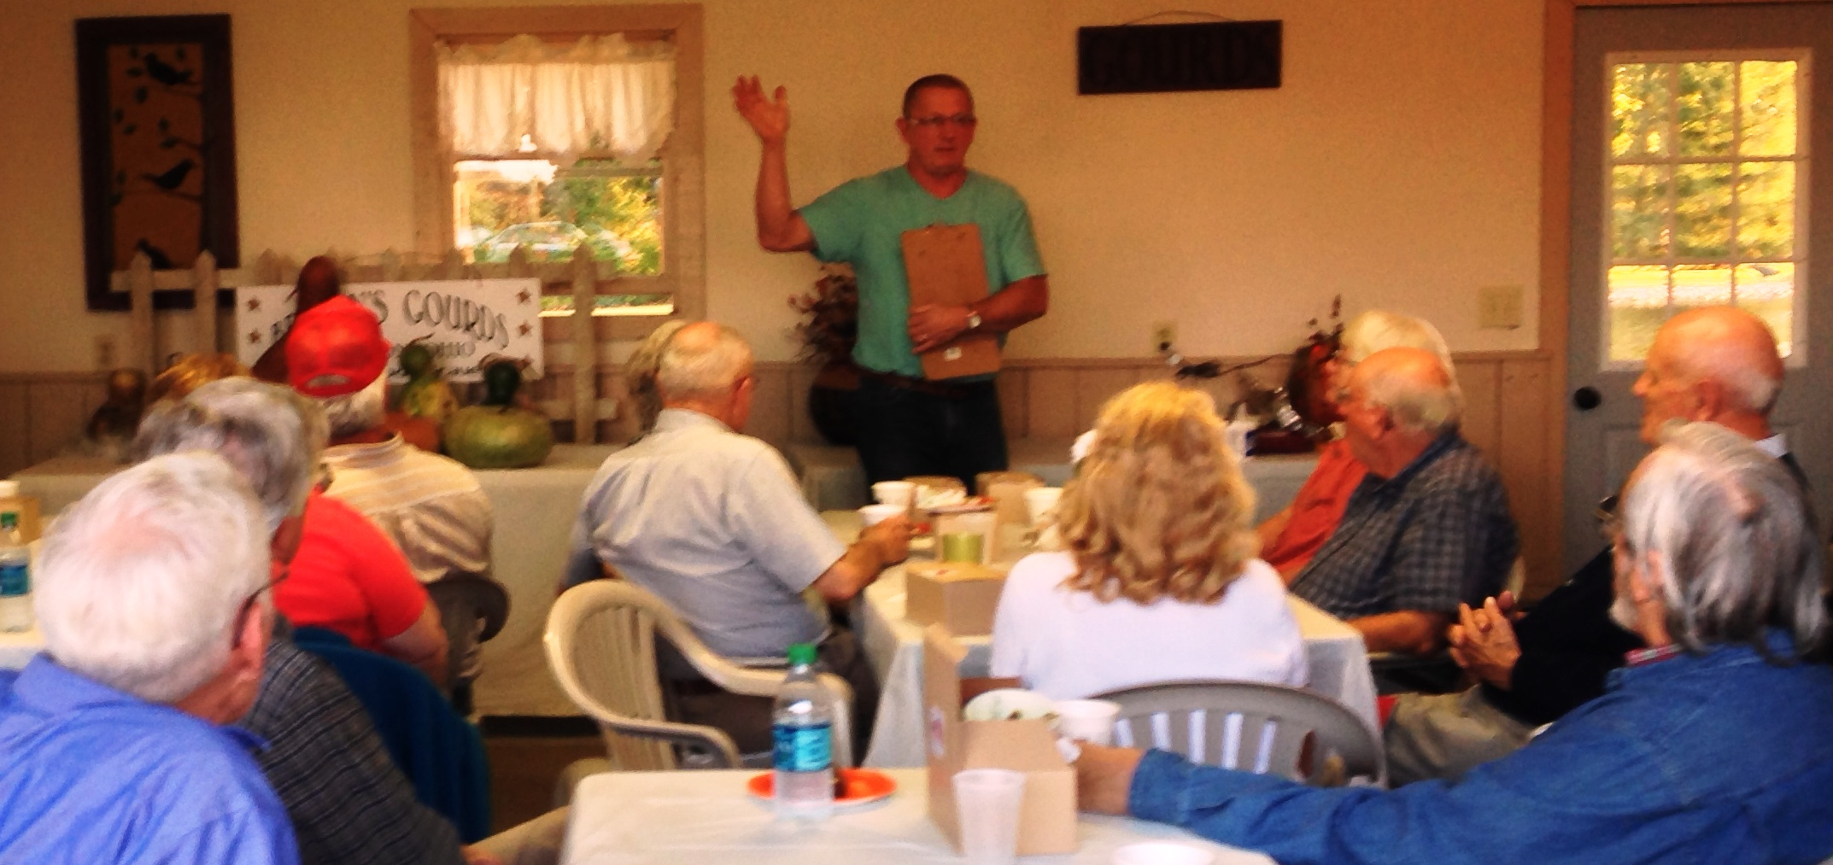

OCTOBER 15TH MEETING:
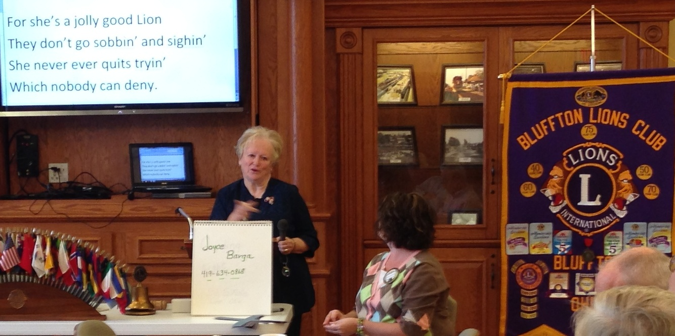
Joyce Barga, a registered nurse, now volunteers at “Guiding Light”, a homeless shelter for pregnant teens located in Lima. Barga shared with the group, “There is a need for this type of organization in the Lima area”. Since its start up this past spring, there have been 8 young women who have lived at the shelter.
The Guiding Light’s vision is dedicated to providing the highest quality educational program with the cornerstone of value learning, self-worth among residents and staff, quality housing to ensure a safe and healthy environment, and transition for teen mothers to a productive and responsible participation in society at large. We look forward to overcoming the epidemic of poverty and long term government assistance.

CORVETTE CHARITY RAFFLE RESULTS:
