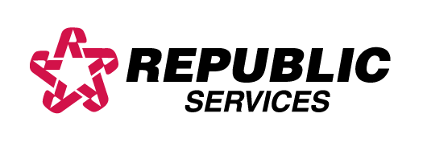

MATERIALS NOT COLLECTED

NO HAZARDOUS OR TOXIC WASTES

NO ASBESTOS OR MATERIAL CONTAINING ASBESTOS

NO LEAD ACID BATTERIES, OIL OR AUTO PARTS

NO INFECTIOUS OR BIOHAZARDOUS WASTE

NO STEEL DRUMS

NO ASHES

NO LARGE DEAD ANIMALS

NO LIQUIDS

NO TIRES

NO APPLIANCES CONTAINING CFC’s (FREON)

