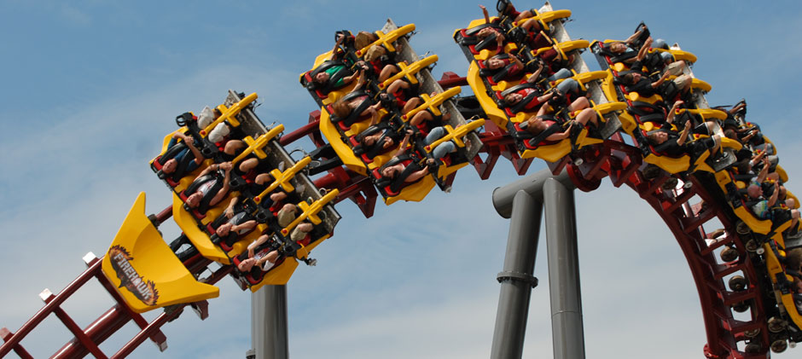WIN
2 Tickets to Kings Island any day before Labor Day 2012 and a $50.00 Gas Card
Do not have to be present to win!
Tickets are available in Administration or Communication
Raffle tickets available for King’s Island or combination of any the below items
(get tickets – Southgate Lanes or Bluffton Hospital)
Colorama sign up, lanes filling up fast!!!
Cost (only $5.00 a game) Bowl 3 games – $15.00
1 for $5.00 |  |  | 3 for $10.00 | 10 for $20.00 | 20 for $30.00 | 30 for $40.00 | 40 for $50.00
1 | $110.00 | Columbus Crew Soccer vs. Real Salt Lake 8pm Game Two tickets & VIP Parking
2 | $100.00 | Comfort Inn Nights Stay
3 | $100.00 | Holiday Inn of Lima Nights Stay
4 | $100.00 | Men’s Dress Watch (Donated by Grab Bag)
5 | $100.00 | Men’s Sports Watch (Donated by Batter Up – Tim Fowler)
6 | $80.00 | Friends Business Source Gift Basket
7 | $50.00 | Charles Construction Basket
8 | $50.00 | Charles Construction Basket
9 | $50.00 | Full Body Massage Peg Whitmer
10 | $40.00 | Bocce Ball / French outdoor yard (bowling style) game (by Bluffton Hospital)
11 | $30.00 | OSU Mouse Pad / OSU Magnet for Car / OSU doll (by Bluffton Hospital)
12 | $30.00 | Rodabaugh Meat / 15# Sausage package
13 | $35.00 | Double special freezer wine bag & 2 bottles of wine (by Hospital & Di Stratton)
14 | $27.00 | Quoits Yard Ring toss Game / $15 Bowling Passes (by Hospital & Southgate Lanes)
15 | $30.00 | Tervis Tumbler 16 oz ($15) Bowling Passes ($15) (by Hospital & Southgate Lanes)
16 | $25.00 | Logan’s Pub (Irish Restaurant) Main Street Findlay
17 | $25.00 | Henry’s Restaurant $10 / Southgate Lane Bowling passes $15.00
18 | $25.00 | $10.00 Dietsch’s Brothers and Southgate Lane Bowling passes $15.00
19 | $25.00 | $10.00 Happy Daz Lima Ohio and Southgate Lane Bowling passes $15.00
20 | $25.00 | OSU Picnic Bucket and glass set (Donated by Bluffton Hospital)
21 | $25.00 | Sam’s Gift Card
22 | $25.00 | Sam’s Gift Card
23 | $25.00 | Special freezer wine Bag and Bottle of Wine (Donated by Hospital and Di Stratton)
24 | $22.00 | $10 Shirley’s Popcorn / 4 Shannon Theatre Movie Passes
25 | $20.00 | Henry’s Restaurant
26 | $20.00 | Henry’s Restaurant
27 | $20.00 | Jeannie’s Kitchen
28 | $20.00 | Jeannie’s Kitchen
29 | $20.00 | Packard Grille
30 | $20.00 | Findlay Inn Grill
31 | $20.00 | Q BBQ Lima Ohio
32 | $20.00 | Beer Barrel Lima Ohio
33 | $20.00 | Beer Barrel Lima Ohio
34 | $20.00 | Giant Yard Pick Up Sticks (Donated by Bluffton Hospital)
35 | $20.00 | Tervis Tumbler 24oz (Donated by Bluffton Hospital)
36 |  | $checking on value 18 hole round of golf / green fees Springbrook Golf Club
37 |  | $checking on value 18 hole round of golf / green fees Indianbrook Golf Club
38 |  | Wal-Mart / Lima Ohio Gift Certificates Coming
39 |  | Thirsty’s
40 |  | Thirsty’s
 |  | More Prizes still coming (ones listed in red are on the way)

